Project Design Phase-II

Data Flow Diagram & User Stories

|  |  |
| --- | --- |
| Date | **15 October 2022** |
| Team ID | **PNT2022TMID05270** |
| Project Name | **Project – Smart Solutions for Railways** |
| Maximum Marks | **4 Marks** |

**Data Flow Diagrams:**

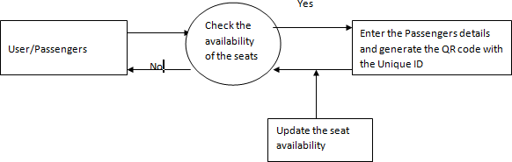

**Data Flow Diagram (level 0):**

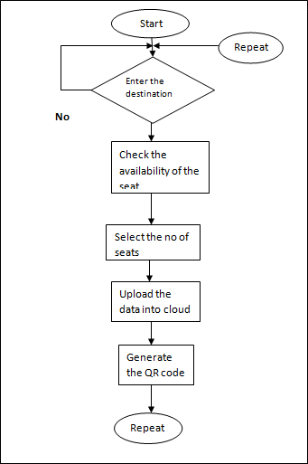

**User Stories:** List all the user stories for the product:

|  |  |  |  |  |  |  |
| --- | --- | --- | --- | --- | --- | --- |
| **User Type** | **Functional Requirement**  **(Epic)** | **User Story Number** | **User Story / Task** | **Acceptance criteria** | **Priority** | **Release** |
| Customer (Mobile user) | Registration | USN-1 | As a user, I can register for the application by entering my email, password, and confirming  my password. | I can access my account / dashboard | High | Sprint-1 |
|  |  | USN-2 | As a user, I will receive confirmation email once I have registered for the application | I can receive confirmation email & click confirm | High | Sprint-1 |
|  |  | USN-3 | As a user, I can register for the application through Facebook | I can register & access the  dashboard with Facebook Login | Low | Sprint-2 |
|  |  | USN-4 | As a user, I can register for the application through Gmail | I can register & access the dashboard with Gmail | Medium | Sprint-1 |
|  | Login | USN-5 | As a user, I can log into the application by entering email & password | I can access easily to go dashboard | High | Sprint-1 |
|  | Interface | USN-6 | As a user, the interface should be user friendly manner | I can access the application easily | High | Sprint-1 |
| Customer (Web user) | Dashboard | WUSN-1 | As a Web user, I can register & access the specific information (maps, seats availability,  book tickets, etc…) | I can easily track the train location | High | Sprint-1 |
| Customer Care Executive | View manner | CCE-1 | As a customer care, I can view the data whenever needed | I can easy to view the passengers detail when  TTR scans the QR code | High | Sprint-1 |
|  | Detected | CCE-2 | As a customer care, I can easily access the users details | I can easily check the seat availability | High | Sprint-1 |
|  | Monitor | CCE-3 | As a customer care, I can track the location of the train | I can easily monitor the location of the train | Medium | Sprint-1 |
| Administrator | Risk Tolerant | ADMIN-1 | As an Administrator, who can handle the system update & take care of the application | Admin should monitor the system properly | High | Sprint-2 |